**INTRODUCTION:**

**(THE DISCUSSION IN CLASS LED OUR GROUP TO RESEARCH WHAT A SMART SAFE CAR REALLY MEANS AND WHAT ARE THE REQUIREMENTS DEFINED.)**

=>Vehicle safety features have come a long way over the years.

=>Features such as crumple zones, seat belts and airbags all provide protection of you have a crash, however active safety assist technologies which can prevent a crash from occurring are now a significant point of differentiation.

**=>The combination of a sound structure, good restraint systems and active safety assist technologies provided the best chance of survival in a crash.**

**=>You may even avoid one altogether.**

The safety of a car is based around:

*Structural integrity* – how the shell of a vehicle withstands and channels crash forces away from occupants. This varies substantially from make to make and model to model. A sound structure is vital when it comes to saving lives.

*Passive safety features* – built-in safety features such as airbags, antilock braking systems (ABS), electronic stability control (ESC), seat belts and seat belt pre-tensioners help prevent or manage the forces of impact. All are critical features.

*Safety assist technologies* – semi-autonomous and autonomous safety technologies which assist the driver in avoiding or reducing the severity of a crash. These include blind spot monitoring (BSM) autonomous emergency braking (AEB), active lane keep assist (LKA) and intelligent speed adaptation (ISA)

**Therefore along with our research and class discussion we have decided to Create a smart car that has the following added safety assist technologies to ensure the safety of its passengers :**

1) Controlled cruising of car using adaptive control algorithm for continuous maintaining the car speed and inter-car distance

2) Accident detection and tracking system using ARM based GSM and GPS

**REQUIREMENTS FROM THE SYSTEM**

**(We first determined how we want the system to work and what we expect from our system)**

1) Eliminate the time taken for the first aid victims, in reaching the severe accident occurred places.

2) To alert the nearby vehicles through the ZIGBEE TRANSCEIVER, away from the line of sight.

3) Easy Identification of the crashed vehicles in the places like hill stations with fog with the help of GPS LOCATION accessing services.

4) If the car in front breaks the cars in the back break too.

**DEVELOPMENT :**

**DESIGN REQUIREMENTS :**

**(The system requirement phase helped us decide what sort of tools we would require.**

**To determine the right tools we had class discussions along with our teacher who suggested zigbee and the ARM processor)**

**ZIG BEE:** Zig Bee is a specification for a suite of high level Communication protocol using small, lowpower digital radios based on an IEEE 802.11a standard for personal area networks.

The low cost allows the technology to be widely deployed in wireless control and monitoring applications. Low power-usage allows longer life with smaller batteries. Mesh networking provides high reliability and more extensive range. The technology is intended to be simpler and less expensive than other WPANs such as Bluetooth.

**GSM MODULE** The Arduino GSM Shield allows a board to connect to the internet, make/receive voice calls and send/receive SMS messages.

**GPS MODULE** :A GPS navigation device is a device that accurately calculates location by receiving information from GPS satellites. GPS devices may have capabilities such as: 1)Maps, including street maps, displayed in human readable format via text or in a graphical format,

2)Turn-by-turn navigation directions to a human in charge of a vehicle or vessel via text or speech, 3)Directions fed directly to a autonomous vehicle such as a robotic probe, Smart Alert System For Vehicles International Conference on Emerging Trend in Engineering and Management Research 36 | Page (ICETEMR-2016) 4)Traffic congestion maps and suggested alternative directions

**VIBRATION SENSOR:** Working voltage: 12VDC⎫ Operating current: 10mA(Max)⎫ Stand by current (When at rest): 0.3mA(Max)⎫ Output mode: high/low voltage signal level(alternative)⎫ Sensing sensitivity: Adjustable⎫

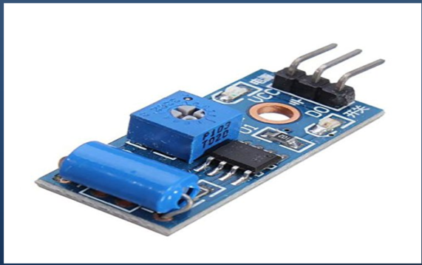

**THERMAL SENSOR** Its trigger when the vibration output is high and its provide by the microcontroller . Once the output of this sensor exceed the threshold level its output is high say(`1`). Then the microcontroller provides trigger to the GPS module and then perform the process.

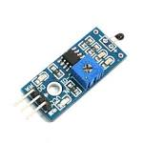

**Microcontroller** Due to the requirement of the multiple receiver and transmitter pins(i.e. Rx and Tx). Therefore we must use a controller with many pins like used ARM Therefore usage of this lower end process, the cost of the project be reduced.

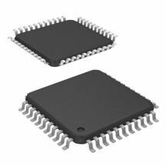

**LCD Display** The 16*2 Character LCD display is used to display the text message that received.Initially the LCD will display there is “no alert”. When the vehicle enters the zone of accident detected, it will display an Alert message as “EMERGENCY” in a two linesof the display.This Display uses three Control pins and 8 Data pins from the microcontroller.

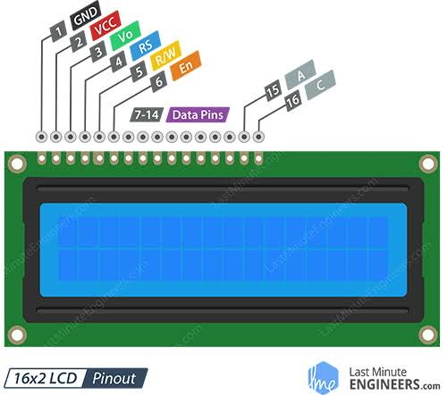

**ULTRASONIC SENSOR:**

An **ultrasonic sensor** is a speaker or microphone that emits or receivesultrasonic sounds. There is also a type that can handle both emission and reception.

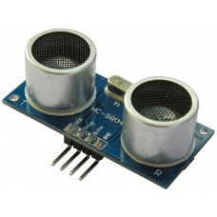 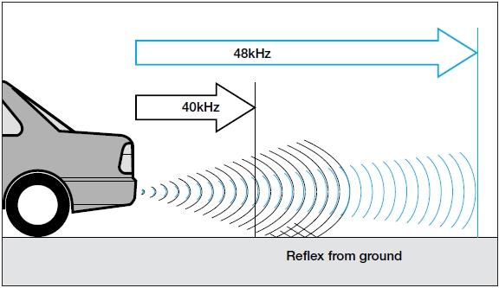

**SYSTEM INPUTS:**

**(We used System inputs as a rough input definition which helped us form the functions required in the next phase. These inputs combine objects already present in a car with objects we will add to the car )**

1) Speed from a speedometer

3) Output from ultrasonic sensor

4) Output from vibration sensor

5) Output from thermal sensor

already present in the car:

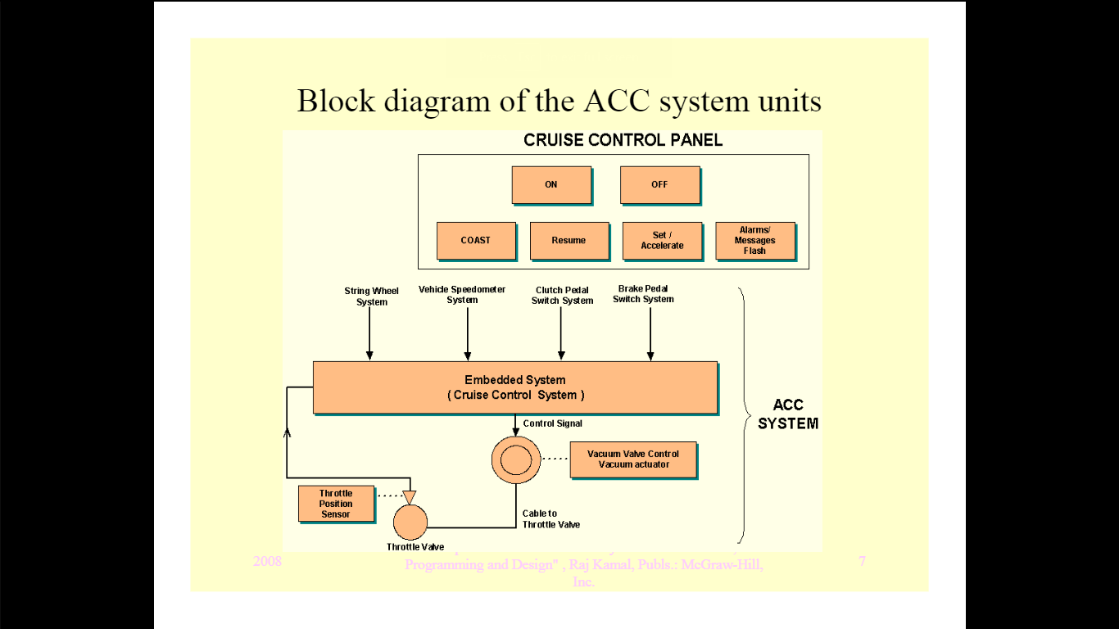

**DESIGN:**

**(IN THIS PHASE WE CREATED A ROUGH DIAGRAM OF THE DESIGN OF THE SYSTEM )**

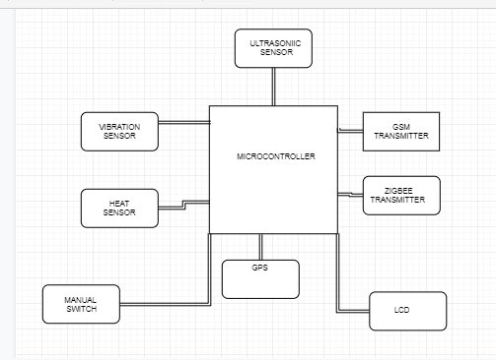

1. A manual switch is added to switch on the safety system
2. An ultrasonic sensor is placed at the front of the car to repeatedly emit pulse waves to check the distance between car and a car in the front
3. When the car in front is too close the sensor alerts the system which then takes over the break and a warning message is shown on the LCD
4. Vibration and Thermal sensors are placed in the car to detect an accident
5. The GPS system is added to locate the car in case of an accident
6. Gsm transmitter is used to send alert messages to surrounding cars.

**DEPLOYMENT :**

**(IN THIS PHASE WE FIRST DEFINED THE ROUGH WORKING OF THE SYSTEM**

**WHEN ALL THE MODULES ARE IN PLACE**

**=>WE THEN DEFINED THE FUNCTIONS AND SCENARIOS IN WHICH THE FUNCTIONS ARE CALLED )**

**WORKING:**

1) Cruise control system takes charge of controlling the throttle position from the driver and

enables the cruising of the vehicle at the preset constant speed. An ultrasonic sensor helps in

maintaining intercar distance.

2) The ultrasonic sensor periodically measures the distance of the car in front

3) The brake is controlled when the safe distance is not maintained and warning message is flashed

on the LCD

4) Once the accident occurrs, the vibration sensor and thermal sensor output output is checked.

5) If it is beyond the threshold level it will be high then the controller accesses the GPS location

and transmits it to the mobile phones with the help of GSM module.

6) Through the Zigbee Transceiver it can send the nearby vehicles which presents within the limit

the ALERT message saying ” accident occurred within the region

**FUNCTIONS DEFINED IN SYSETEM :**

**1) auto_brake :** takes control of break when car comes too close to the car or object in the front . =>This is sensed by the ultrasonic sensor which periodically measures the distance of the car in front.

=>The brake is controlled when the safe distance is not maintained and warning message is flashed on the LCD

**2)lcd_display**: displays:

**1)WARNING DISTANCE** : when the breaks are taken over by the system

**2)ALERT MESSAGE SENT:** when accident occurs lcd displays this message on screen so the person inside the car knows that people are notified and help is on its way

**3)vibration_sensor_triggered and thermal_sensor_triggered:** this function is triggered when accident occurs and sensors sense above normal vibrations and heat

=> the vibration sensor and thermal sensor output is checked.

=>If it is beyond the threshold level it will be high then the controller accesses the GPS location and transmits it to the mobile phones with the help of GSM module.

**4)gps_detect:** this function detects the location of the vehicle when the sensors are triggered. Once the accident occurrs,

**5)message_send:** this fucntion uses gsm module to send alert message

**6)zigbeealert_on :** this function uses zigbee Transceiver to send an alert to the nearby vehicles which presents within the limit the ALERT message saying ” accident occurred within the region

**DEPLOYMENT SCENARIOS :**

**WHEN THE CAR IS DRIVING ON THE ROAD AND IT COMES TOO CLOSE TO A CAR OR OBJECT IN THE FRONT :**

1) auto_break function is called

2)lcd_display_1 is called

**WHEN ACCIDENT OCCURS :**

1) vibration_sensor_triggered and thermal_sensor_triggered

2) gps_detect:

3)message_send

4)zigbeealert_on

**SUPPORT/UPGRADE/RETIREMENT:**

We believe that the technology of safe cars needs to keep improving to the point of nearperfection.

For this to be possible we need to completely remove the possibility of human error**.**

**So**me future technology to add to the safe car would be :

1)Add sensors on all sides of the car so that the car to enable autonomous :

a)parking

b)acceleration

c)reversing etc.

2) Add virtual communication between cars without human interaction to select best routes for the car

3)remote shutdown of car incase the driver seems incapable to drive eg) under influence, over-exhausted, over-speeding

**COST ESTIMATION:**

|  |  |
| --- | --- |
| **Components** | **Price** |
| **1.Zig Bee** | **980.00** |
| **2.GSM Module/GPS Module** | **2199.00** |
| **3.Vibration Sensor** | **192.00** |
| **4.Thermal Sensor** | **1474.00** |
| **5.ARM Processor** | **2410.00** |
| **6.16*2 Character LCD Display** | **450.00** |
| **7.Buzzer** | **150.00** |
| **8. Ultrasonic Sensor** | **2229** |

Total 10,084